Hira Cabinent Images Tutorial

- For the goal of this tutorial, we need to update images in the hira cabinents, there are six to my knowledge for the specfics of this task. The URL is http://groups.nscl.msu.edu/hira/equipment.htm . If you scroll down you should see 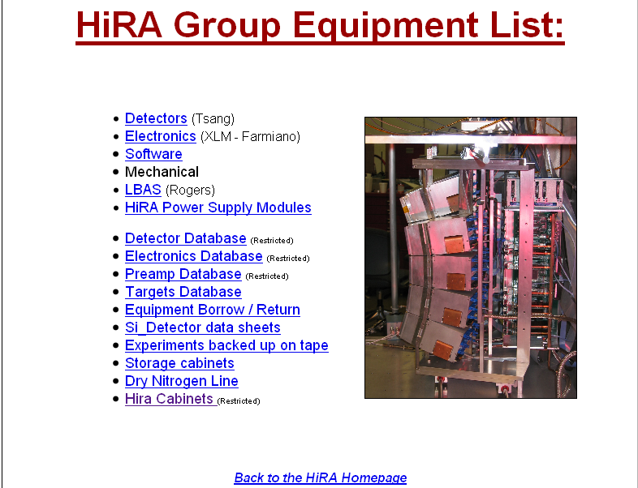
- Click this, and you will notice it is restricted; you will have to obtain the username and password from Betty, or your supervisor. Once you are able to login to view the hira cabinets, you should about 6 tables with multiple shelves with multiple thumbnails. Each table describes an individual cabinent. Most cabinents have 4-5 shelfs with items on them.
- The hiraCabinents site is made with html. So I hope you’ve read some html tutorials or some of my tutorials on editing links and such. If not, trust me go back and learn html, it will take you 15 minutes and you will be a pro.
- So lets say you went to the specified cabinets Betty has told you update pictures of. Cabinet 006 for example. So lets define a protocol for taking pictures.
- Always take at least once picture of the entire cabinent, showing all the shelfs.
- Take a picture of each shelf for the shelf number link
- Take a picture of every item/box/view in the cabinent and sort accordingly.
Changing website around…
      - So now we have our new pictures, inside the hiracabinents folder in 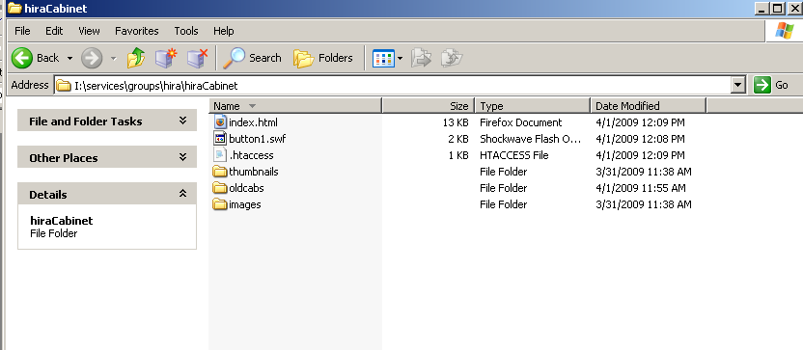
      - notice a few things about our hiraCabinent folder, notice the files here, I will explain them here.
      - index.html is our index page for the hiraCabinents section, this contains the html we will want to edit.
button1.swf, is a back button in flash, that takes the user back to the parent page, don’t mess with this, unless you understand its purpose and its needs.
.htaccess, this is our login script in one sense, this defines how to accept incoming users and what passwds are defined, the passwds are not defined here. Don’t mess with this unless you know the concept behind .htaccess
now lastly we have 3 folders, thumbnails, oldcabs, images, now oldcabs is just a folder storing olde files and folders, nothing too important, I tend to not like to delete stuff because it causes problems.
These other two folders we are very concerned with; thumbnails and images. These should be pretty self explanatory, thumbnails are all the thumbnails stored for the thumbnails in index.html
Whereas images are the larger better quality versions of the images in thumbnails.
      - So here we go, you have your new images, so you should probaly do all your testing on another server because you don’t want to replace the existing hiracab until your sure your down.
      - So on your test server, you could use the library’s server to do tests on, that’s what I do, You should have 4 files essentially. You’ve got index.html, button1.swf, thumbnails, images. Just COPY these files/folders from into your test directory so we can begin editing, make sure you just copy these files and not move them across different drives, or you will cause a loss file storage.
      - YOUR new images should be placed into two of your test folders, thumbnails and images. So you should have two folders with different names but same files in each. You can name each picture however you want, you will probaly want to name it according to [cabinent,shelf,box,view] ect.
      - We later will do conversion in thumbnails folder, but now your are done with the images folder, we do not do any conversion to this folder, this is our main high quality pictures that are linked through the thumbnails.
      - So my understand of the hiracabinets is that they are updated periodically, and have different numbers of shelves during each update. So that means you might have to update the pictures, cabinent names, box names, view names, shelf numbers and anything else. But with dreamweaver it’s a piece of cake.
      - So lets right click on index.html and open it with dreamweaver. You should see something like this, NOTE this tutorial is going to be done mostly in design mode for simplicity. The code mode is not hard at all and is not as slow as design mode. 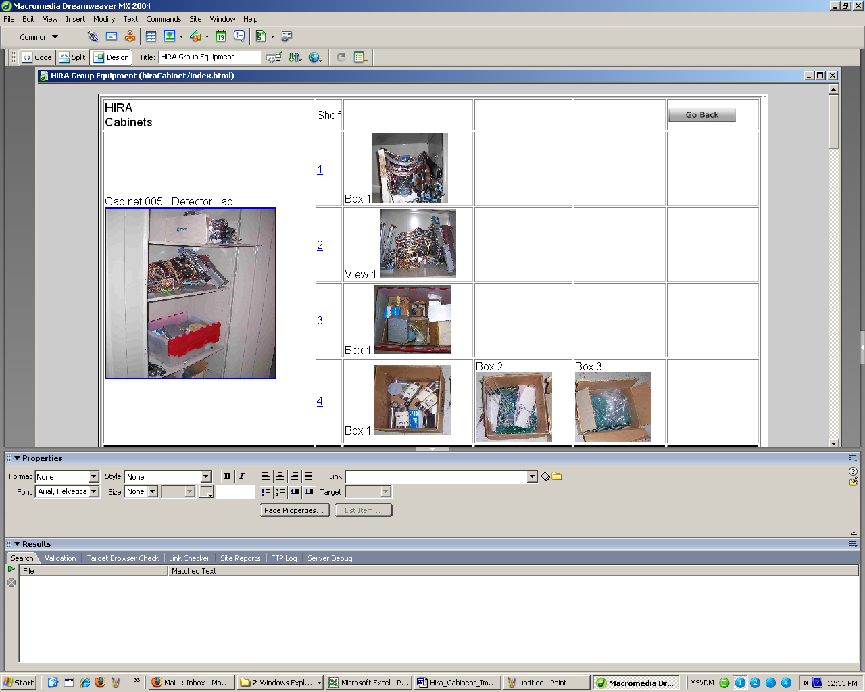
      - Now I’m only going to edit a few pictures step by step so you get the fundamental idea. Lets say I want to update the cabinet picture, 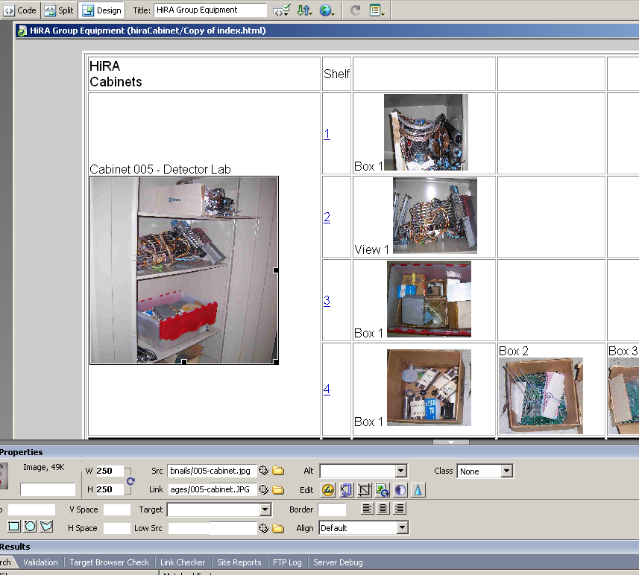
      - So I clicked on the Cabinent 005’s main thumbnail picture, NOTE I never re-size any images outside of dreamweaver; all the image re-sizing is down through html. So After I clicked on this image a few things in our properties box appear. I hope this next step does not complicate you.
      - So we have few properties you should be worried about. [W,H] [Src, Link]
      - Notice that many of these properties don’t look confusing and are not confusing, dreamweaver does a decent job at making web design simplified. But its still slow.
      - So for obious reasons width and height should be edited if your editing the width and height of an image.
      - Src = Source of the image, this src is what will apear on index.html, this will not appear when you click on the image link. NOTE!! All images must be linked to the there corresponding images in the images folder.
      - Link = Link to new filetype, this will link your image to whatever you want.
      - Now for the structure of hiraCabinents page, Src will be your image from the thumbnails folder, and Link will be your image from images folder.
      - Now you may be asking you self “we still have same files in each differing folder”, well here is how we change the thumbnail folder. We need to convert these images to a lower compressed format, whether it be .jpg, .png, .gif, ect.
      - To do this you need an image conveter, simply going to paint and saving a file as a gif or a jpg does not do a good or full conversion if any. You need an actual converter. I suggest you do all your image and thumbnail naming before any conversion, thumbnails and image folder pictures should essentially have same file names but different file types. **read my tutorial on converting images
      - Once you have converted images, your images should be significantly smaller than your images in the images folder, look below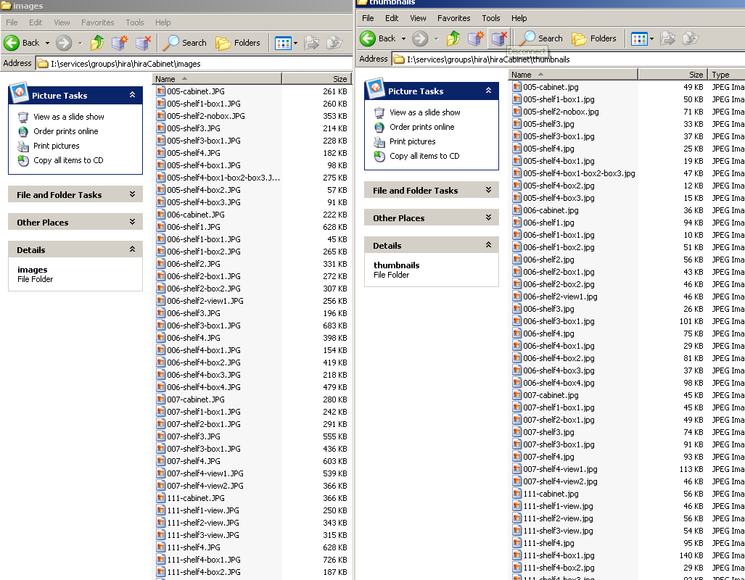
      - I know its hard to see, but look closely, the files go from 500 kb to 30-50 kb for some after the conversion, this makes the page load a lot quicker. Again another reason to learn html because it will explain this. Everytime you go to a webpage it downloads images off site so you can view them, if every image is 500 kb, and theres 50 images, that’s a lot of image downloading your browser is going to do ultimately leading users away from your site.
      - So lets go back a few steps
      - We need to change the filename of src image and link image, for this example “thumbnails/005-cabinet.jpg” is our thumbnail and images/005-cabinet.JPG
remember these filenames are case-sensitive
      - I suggest you do all your naming before any conversion, So lets say you’ve renamed all your images in both folders, and converted all the thumbnail pictures, so now your ready to replace some images.
      - So to replace the thumbnail, you go to Src, and change the existing path to the new path of your new thumbnail. You probaly wont have to change the “thumbnails/” part of the path because that should stay the same in the hiraCab, your going to want to change everything after “thumbnails/” with your new file name. For example I have a file in thumbnails folder called 005-NEWcabinet.jpg, it hosted locally on my desktop pc, it is not the hiraCab website yet. So All I input for Src is “thumbnails/005-NEWcabinet.jpg” and it will replace the existing thumbnail with the new one. The reason I don’t want you guys changing the path too much and hence why I told you to just copy index.html, thumbnails and images folder, button1.swf is so that you don’t have to do major re-editing, CAUSE when your done, all you do is draw your new files/ and folders into the hiraCabinets folder, but again do not replace the exisitng ones just put them in the “oldcabs” folder inside hiraCabinents folder.
      - To replace the link it essentially the same thing, lets say in MY images folder I have a better quality version of thumbnails/005-NEWcabinet.jpg called 005-NEWcabinet.JPG, now notice the differences.
thumbnails/005-NEWcabinet.jpg vs images/005-NEWcabinet.JPG
the only difference is in file type and not file name, Its kind of like overloading the file name with different file types.
      - So in Link field I would enter “images/005-NEWcabinet.JPG” and this would take me to a larger image with better resolution and quality.
      - Once your down, move your old files to “oldcabs” folder for the sake of backups and error rates, and move your new updated hiraCabinets page into the hiraCabinet directory on the hira drive, I:\services\groups\hira\hiraCabinet\
usually something like that path above.
      - and your done, any questions feel free to email me at shayaant@msu.edu

