Irfan View FULL Tutorial: Installing, Updating, Using, Uninstalling

- http://www.irfanview.com/ This website is where you can download updates and the software itself. This software is very easy to use and user friendly I will walk you through the installation process. Click the link above and enter there website. 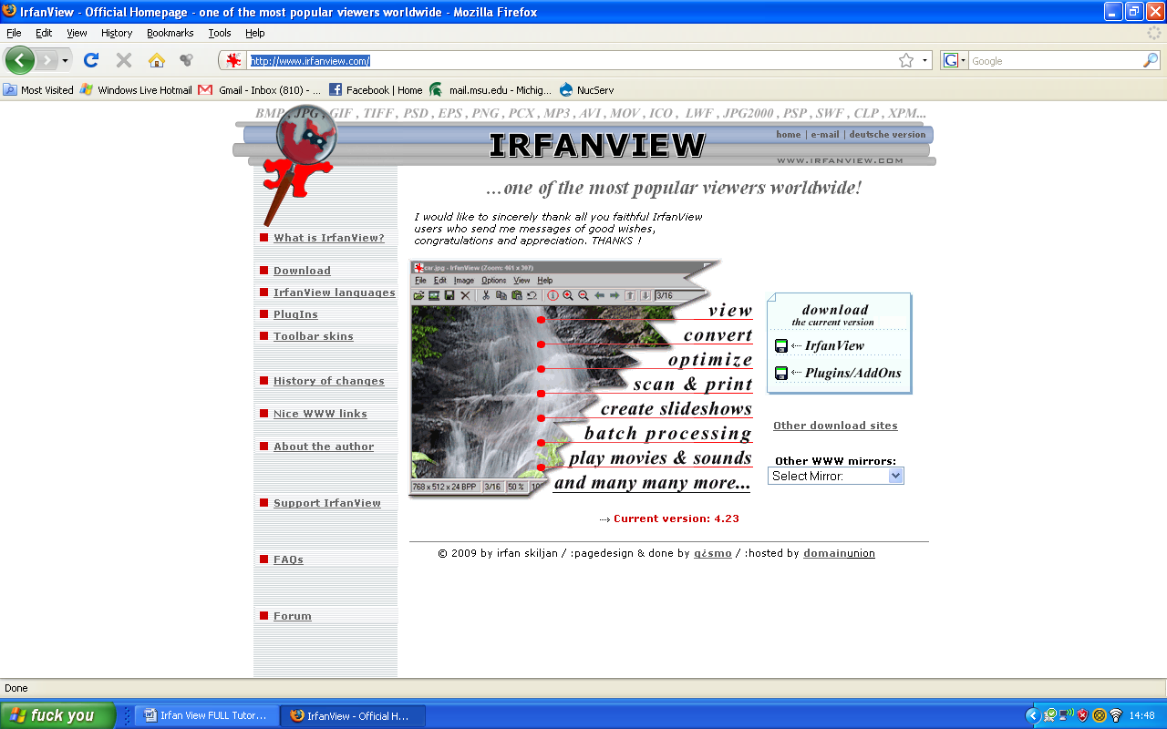
- Click download and or if they’ve changed the site find the download page and download the “.exe” file for Irfanview. Once you’ve download this file your ready to install Irfanview.
- Double click on the setup file, if your downloading the correct website you shouldn’t worry about viruses and spyware, this program is free and widely used, just make sure you are on the correct site and not some other site.
- Once you’ve doubled clicked the setup file a window should open(next page, first image)
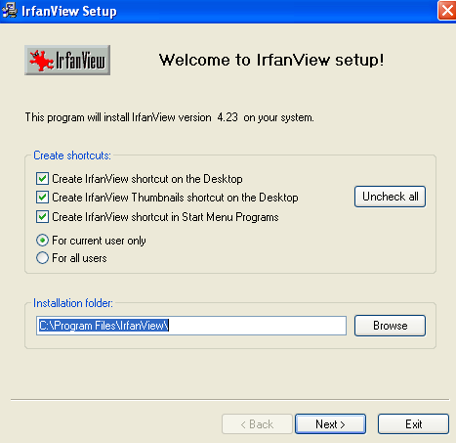
- Make sure everything checked in the picture is checked on your screen, also make sure the default path for installation is in your program files for your main harddrive. Then click next
- After you click next the changelog screen will show up, look at the image below, 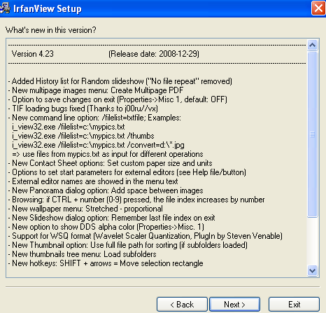
- Just click next and move on to the next screen. Look at the image below
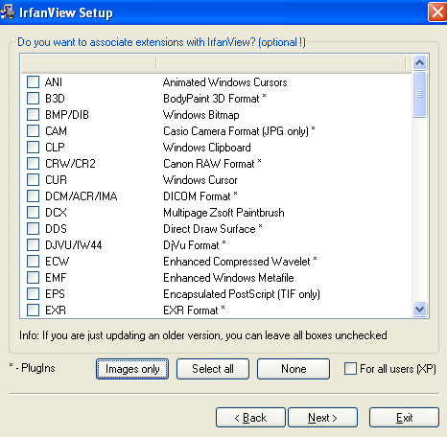

- This is the file types page(image above), this page sets certain images and filetypes to open automatically with IrfanView and not your defaulted programs. If you want to set certain files to open with Irfan, then check what you want and click next, if you don’t want to change anything just click next.
- If this screen(image below) is not in setup then don’t worry about it. This is google toolbar and desktop search add in page, UNCHECK both of these options, you do not need them. Click Next
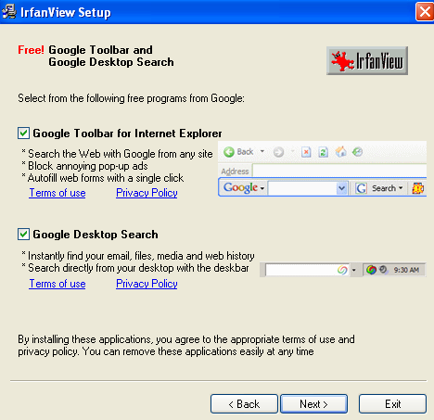
- The next screen(image below) verifies the directory you want the installation to take place at. Just click next because for the most obvious uses, you do not need to mess with this page. 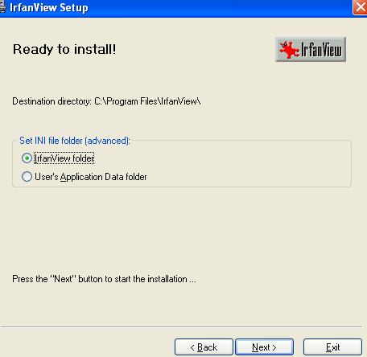
- Now the installation has obviously started and it is usually happens very quickly. The below image should show up after the installation has finished.
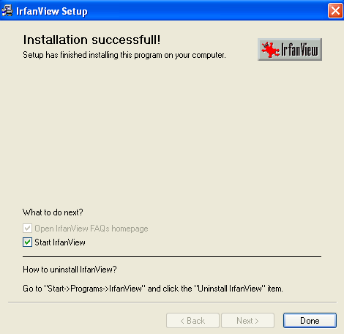
- If you want start using Irfanview leave, the “Start IrfanView” box checked, or just double click icon on your desktop, or go to Start>All programs>IrfanView>IrfanView.exe, otherwise click done.

INSTALLING POSTSCRIPT PLUGIN
- Now for the purpose of IrfanView we need to view multiple postscript files at once in thumbnails views. Now there is a plugin that you have to install in the Irfan Directory.
- http://www.irfanview.com/ Go back to this site and click the link plugins
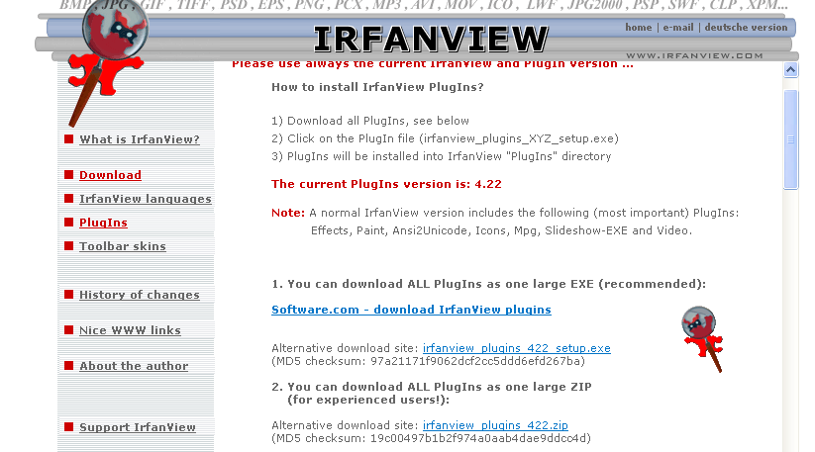
- Now you should be on the plugins page
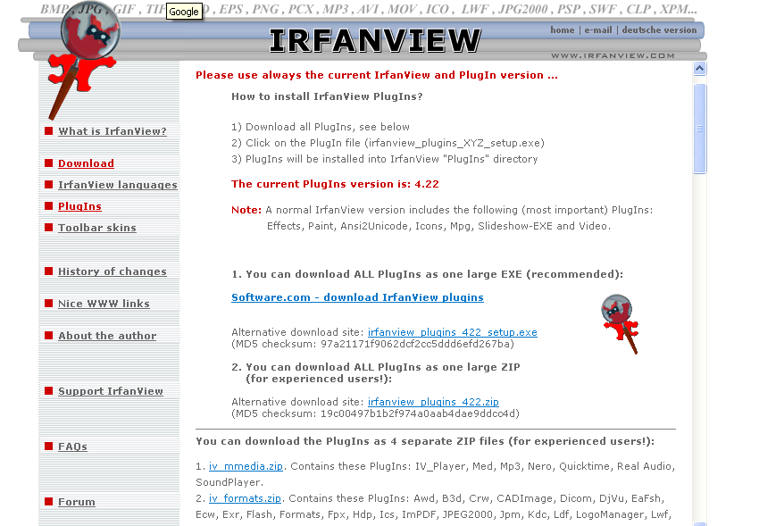
- Now you have to download a .zip file which contains the plugins we desires. The zip file we want is “iv_formats.zip” , so click that and download. If at the time of this tutorial there is “iv_formats.zip” find whatever file has a .ps extension plugin in it. That is the plugin you always want.
- After you have downloaded the correct zip file, you have to extract these files, which should .dll files into your plugins folder. Now where is “plugins” folder. If you correctly installed IrfanView then it should be inside your IrfanView folder. Now I am going to assume whoever reads this cannot find this directory so I will walk you through it. You have to go to your defaulted harddrive, most often the C drive, which should be in my computer folder, which you can usually get to from your desktop or my start menu. Double click that, inside this drive contains all the information and files stored in your harddrive. There should be a folder called “Program Files”, double click that. This is the folder with all your programs. Scroll down till you see a folder called “IrfanView”, double click this folder. Now you should see a folder named “Plugins”, place the contents of the zip file into this folder, do not put the zip in this folder, put the CONTENTS of the zip in this folder. Now your plugin is installed, and now we can work!

USING IRFANVIEW with post script files
- Now this is for Betty and her employees, the ability to thumbnail postscript files is easy to use and install.
- Now IrfanView default installs another program, “IrfanView – Thumbnails”, it should be on your desktop or Start>>All Programs>>IrfanView>>IrfanView – Thumbnails
- This is the program in which you can view multiple postscript files at once.
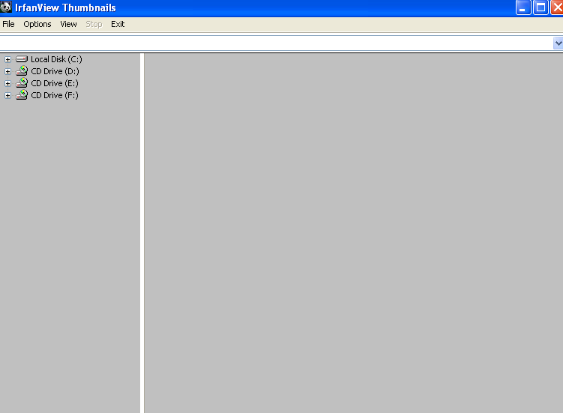
- Since we’ve already installed the plugin this part of the tutorial should be relatively easy. In the image above, you see drives that you are able to expand by clicking the “plus” signs next to them. This navigation bar is meant to locate where the files you want to view are. Look at the image on the next page.
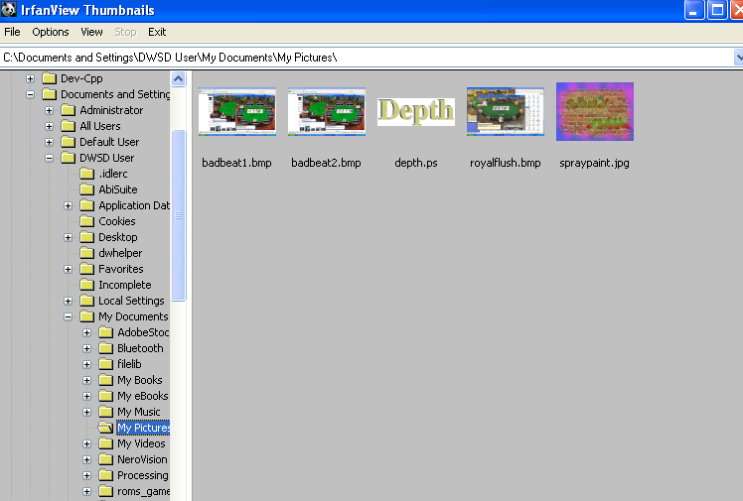
- So as you can see I am able to view depth.ps, which is a post script file as a thumbnail. Now you change how you view your images. In the options tab on the top navigation bar. If you click this tab you will be given multiple options to click from. If you want to sort the thumbnails, you can click this option and see the image below
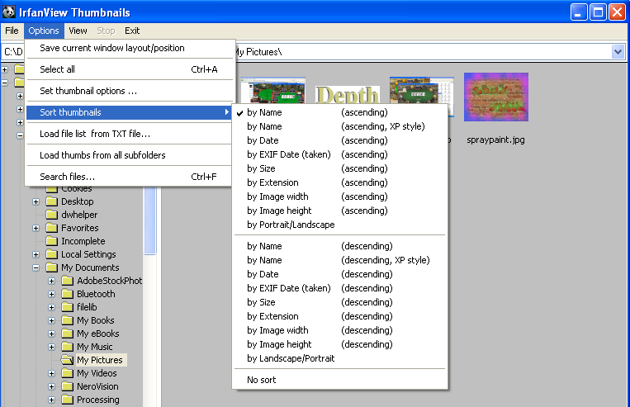
- Clicking any of the sort options will automatically sort, or you can click “no sort”
- If you want to change how you view thumbnails, you have to click “Set thumbnail options ..”
- When you click this option the screen below should appear.
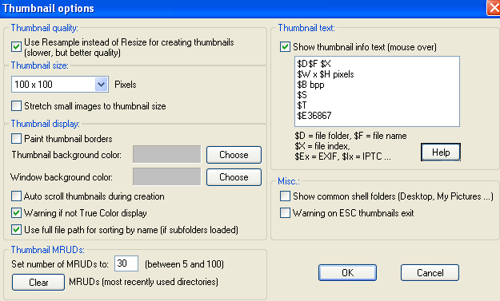
- Here you change the thumbnail size and thumbnail background. After you made your selected changes click “ok” tab at the bottom.

UNISTALLING IRFANVIEW
- To uninstall irfanView, there are multiple paths which this can be done by. The easiest method of doing this is to go to START>>ALL PROGRAMS>>IRFANVIEW>>IrfanView Uninstall, the screen below is what you should see after you have clicked this option.
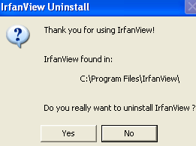
- Click yes and it should uninstall and if it is done correctly, the screen below should appear.
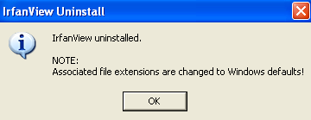
- And your done, wiiii!

