Copying files from one linux server to another

- We have to copy files from hpc server. To do this, you need to connect the hpc linux server which is hpcc.msu.edu and username is bettys username and password, she will have to enter it in.
- Once you are logged into the hpc terminal type “ssh brody” without quotes to gain access to the brody root terminal.
- Now to check your folder contents in the brody terminal, then type “cd imQMD/” then type “ls” to view everything in the imQMD directory. If you are trying to copy from imQMD make sure your terminal is in the specified folder. 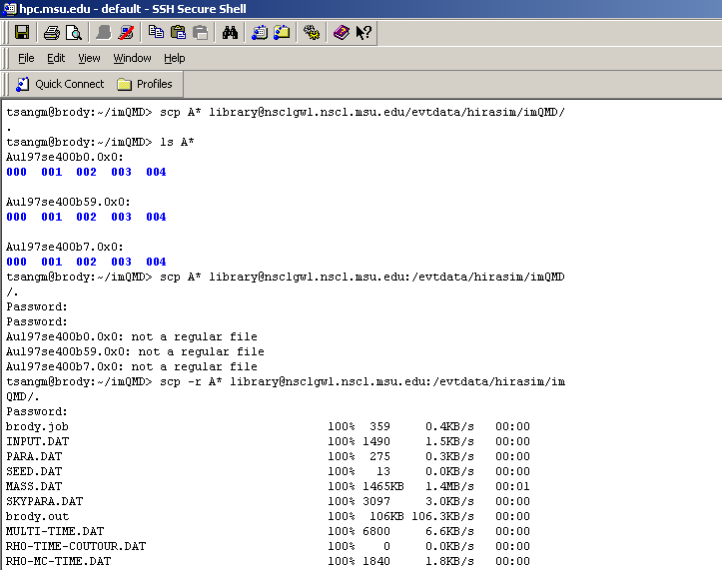
- Then to COPY contents of folders or folders in generals or files you must use this command accordingly.
- “scp -r A* library@nsclgw1.nscl.msu.edu:/evtdata/hirasim/imQMD/.” -without the quotes
- Now this may not be the exact command line you may use, note “A*” is copying all the contents that start with an “A” to library@nsclgw1.nscl.msu.edu:/evtdata/hirasim/imQMD/ so essentially you could put C* and it would copy all contents in the specified folder starting with a C.
- This copying process may take a long time depending on the contents your transferring over to the specified server so be patient and do NOT hit any keys while the transfer process is going on.
- So now I assume the files have been copied into your specified directory. So now login to the library ssh client as library, under element and specified password provided to library employees. CHECK CONNECT TO LINUX TERMINAL PROCEDURE!
- Once your logged into you will want to navigate to evtdata drive in the terminal, navigation through the NSCL unix server can be kind of tricky, so I’ll walk you through it.
  - I suggest you read the “connect to linux terminal” procedure but if your at this step with no problems then you should be a pro with linux right now ☺
  - Once you’ve logged into NSCL unix server, under the user name “element” and the specified passwords, you should see something like 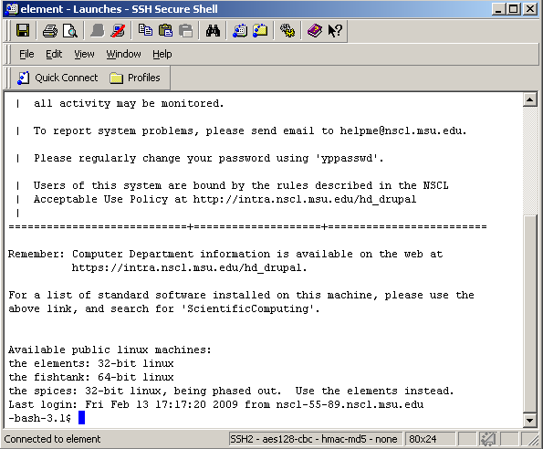
  - So where bash 3.1 is , there is a cursor where you type all your commands and information, so just to get a sense of where we are at , type ls to see where you are in the directory. 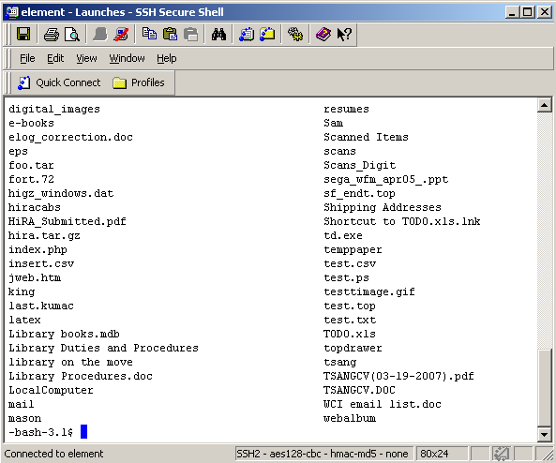
  - this is a list of folders and files inside the directory I am currently in, but I want to get to evtdata folder, so here we go, we need to get to the main root of our directories and move from there. To do this I type “cd ..” –without quotes, notice those are two periods “..” not colons or semi-colons. When you type this single command it takes you up a directory, now there are other commands that take you to the central root, but you probably don’t have permission to use those commands. For now just go up directories using “cd ..” –also notice the space in between.
  - 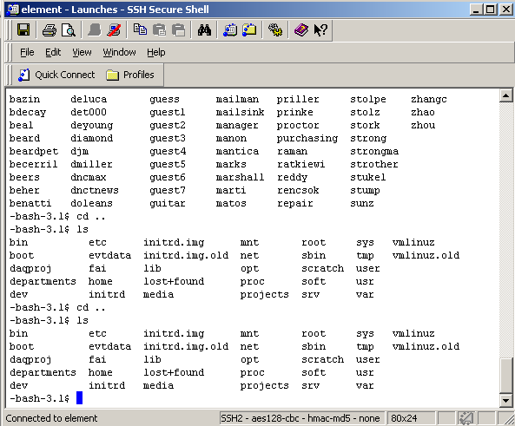
  - As you can see I used “cd ..” to move up directories and now I make the realization that I can no longer move up anymore directories with this command. This image above is the current format of unix NSCL server, if you haven’t already noticed evtdata is present in this root directory. So now we type “cd evtdata” remember no quotes, and the specified directory should open. After I use “cd evtdata” I use the “ls” command to view all the files and folders, like in the image below.
  - 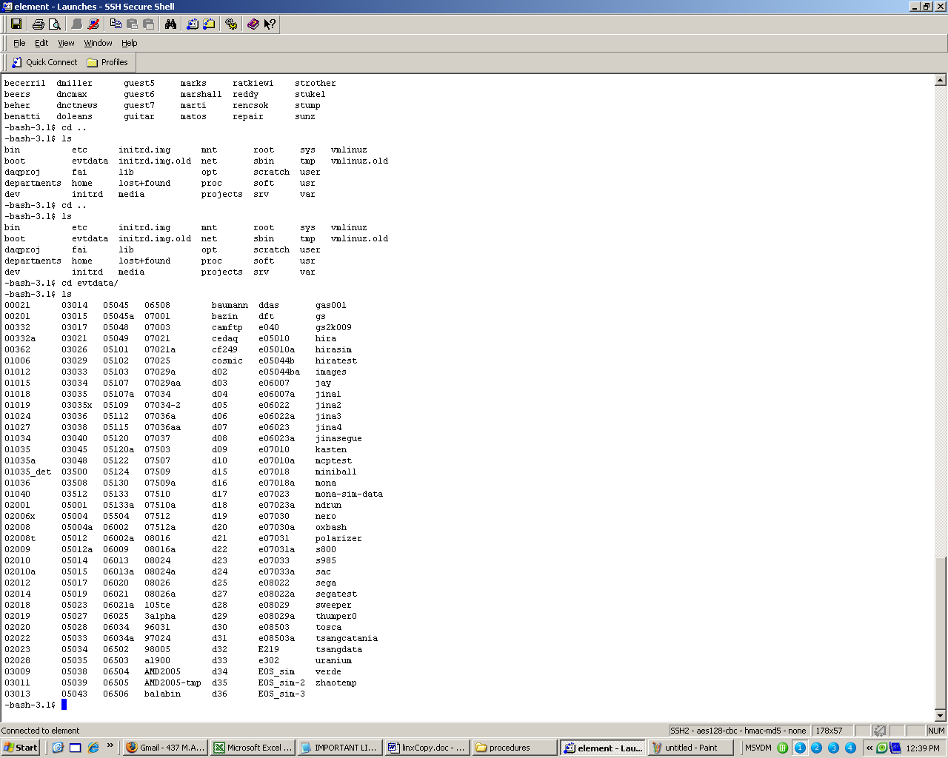
  - As you can see I posted a larger image so you could see the grand scheme of my commands at work. If you are here then you are doing great if you are have problems consult Betty or myself for help.
  - Next we have to go to the folders that would be specified for this task.
  - cd hirasim
  - ls
  - cd imQMD
  - ls
  - 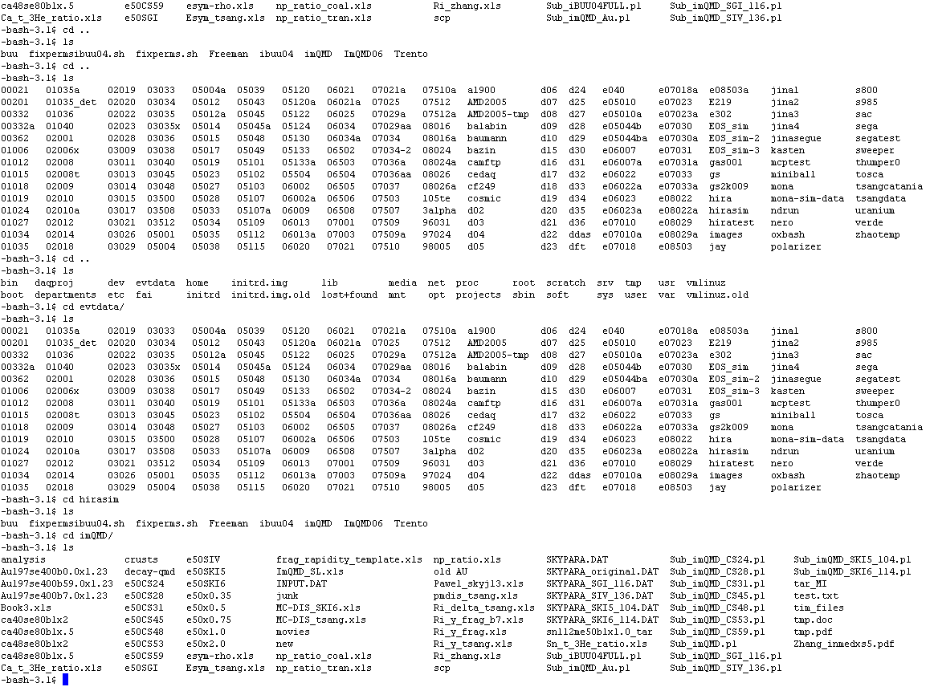
  - In the image above I go through step by step the process to get to the imQMD folder in the terminal. Notice the 4 corner stars are where the commands are. The 3 folders are tabbed using lines, they start with AU197, these folders are the ones you will be working with when compressing.

  - 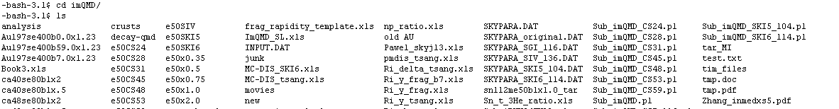
  - So lets start with the first folder “Au197se400b0.0x1.23” I will not go through the other two, just one because after you’ve done one you will be ready to do the others.
  - First things first lets go into that directory, so we type “cd Au197se400b0.0x1.23” and “ls” to see what’s in the directory.
  - You should see 5 folders, named 000 or 001 or 100 or 101. These folders are your first compression task; the second compression has to do with an individual file that needs individual compression. So for now we will deal with the first compression process.
  - To compress the 5 folders we go inside the AU directory, which you should already be in, if you don’t see the 5 numbered folders then your in the wrong place and need to go back a few steps. Once your in your “Au197se400b0.0x1.23” directory and you’ve made sure your 4 target folders are there, you type one command to that will ONLY compress folders and not files, this is good because I see there are other files in the Au197se400b0.0x1.23 folder and we probably don’t want to compress those now. The command is

  - for f in `ls`; do tar -czf ${f}.tar $f; done
  - The command above is meant to be typed exactly as it is stated, it would be better for you to copy and past this command, to insert copied information into the terminal hit SHIFT+INSERT keys on your keyboard.
  - Once you’ve entered the above command hit enter and DO NOT TOUCH THE TERMINAL, if you hit any keys while the compression is going the compression will change, in Linux when your doing processes you can change events by just hitting “h” for example will do something you definitely don’t want. After you hit enter you should notice nothing really happens in your window but things are definitely happening, YOU should see the image below 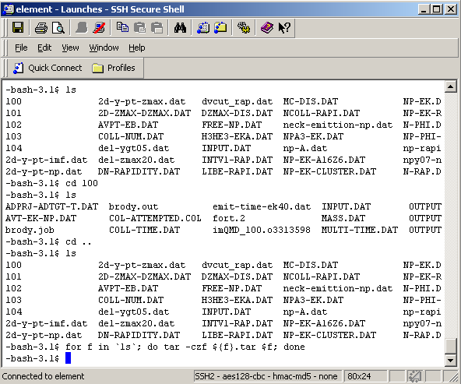
  - Since my compression finished I was taken back to the command terminal and If I got to my evtdata folder in windows I can see that K:\hirasim\imQMD\Au197se400b0.0x1.23\ this is the current location for evtdata on library computer, I cannot predict changes to the server in the future. But when you do manage locate your specified directory you will see 5 “.tar” files, this means your files have been compressed, these compression are big files so don’t expect 30mb compressed folder, expect 100mb-500mb .tar files.
  - If windows is not your thing check linux, if your still in Au197se400b0.0x1.23 directory in the terminal type “ls” to see if it worked, check image below.
  - 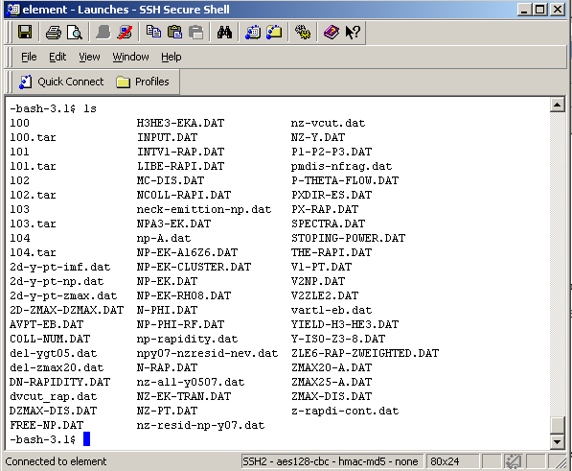
  - So as you can see in image above where 100,101,102,103,104 folders are, there are no 100.tar,101.tar,102.tar,103.tar,104.tar that have been all created, now what if I want to check the file size, to make sure the files were actually created, type “ls –al” 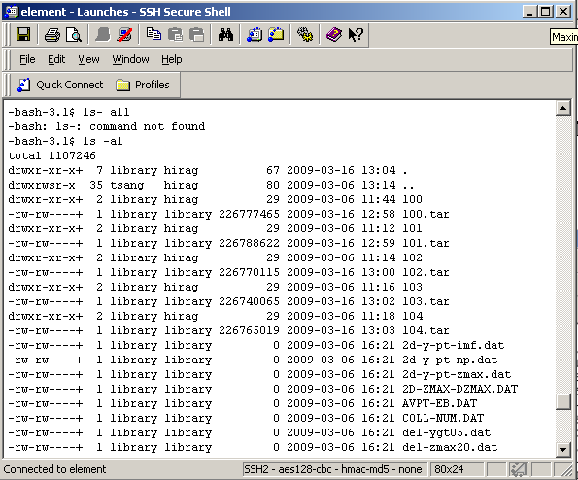
  - So now we can see the .tar files are about 225 mb each, cause that previous commands shows us file permissions and other information about the file or folder.
  - Congrats you’ve achieved the first part of our compression process the next part entails.
  - Our next goal is to compress an individual file inside the 100,101 directories called OUTPUT.TIM
  - This file is located inside 100,101 folders not the .tar files. So our first step is go inside the 5 folders, we have to do this manually for each one, there is no fancy command that does that yet.
  - So we do “cd 100” and type “ls” of course so we can see where OUTPUT.TIM is.
  - 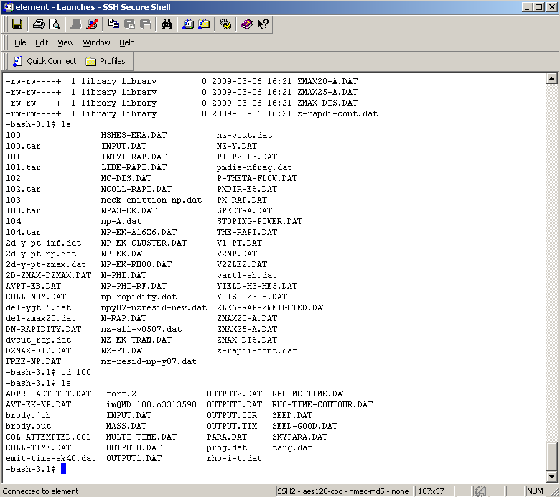
  - If you looking through my steps which I've highlighted by use of the infamous 4-corner star, you’ll see how I got there and you should also notice our file, So now that we’ve located this file, we have two options for compressing it, we can compress it through linux or windows, for this tutorial I will explain the windows side of this compression, cause it is easier to use and entails better compression methods for large files, and you will be able to see your file being compressed, while in linux you have to assume your work is being done via command line.
  - So we will use WinRAR to compress the TIM file. You must locate the TIM file in windows. You should be able to find it quite quickly, the evtdata drive should be mapped for you or it is mapped on library computer.
  - 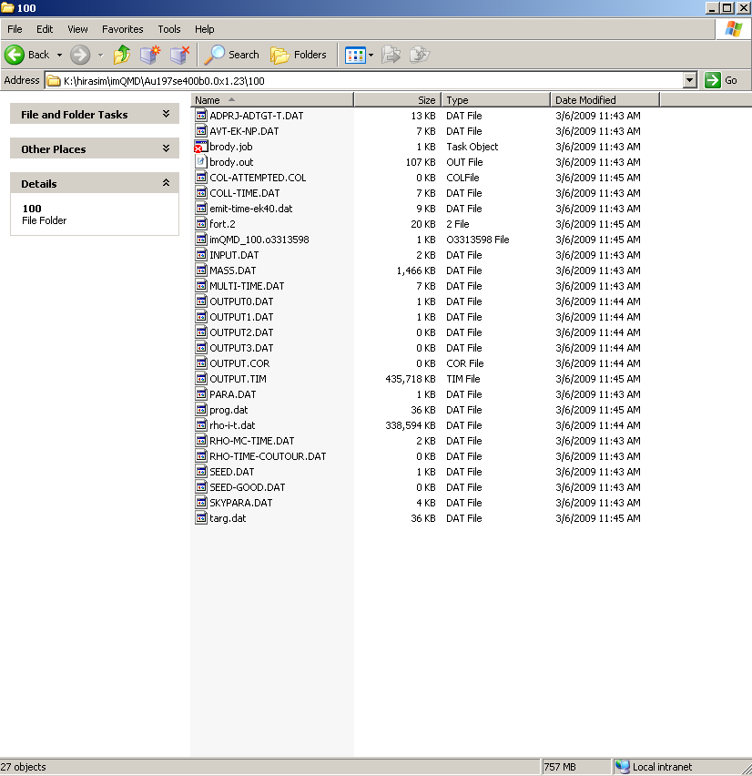
  - I pointed to OUTPUT.TIM, so you can see where it is physically, if you take a look at this directory path,
K:\hirasim\imQMD\Au197se400b0.0x1.23\100
other than the K:\ part, the rest of the path maps how you get to the AU and 100 folders inside evtdata directory, but you could probably just copy and past that path and it will take you to the 100 folder.
  - To compress this file, refer to my WINRAR installation procedure to install it, and if you already know how to compress files in windows, please go ahead but there is a naming system by which you should follow
  - MAINFoldername-2ndfoldername-.rar
  - When I say folder name I mean if I want to compressed the 100 folder inside the Au197se400b0.0x1.23 folder, then my OUTPUT.TIM rar file would be named as followed
  - Au197se400b0-100.rar
See what I did, I eliminated everything after the decimal and add the sub folder name which is a 100, that contains the desired OUTPUT.TIM
  - I will assume you have read how to install winrar, but I will still show you how to compress this file with winrar, if you’ve installed winrar correctly, you should be able to right click on the OUTPUT.TIM file and see a bundle of options you can click on. Look at image below
  - 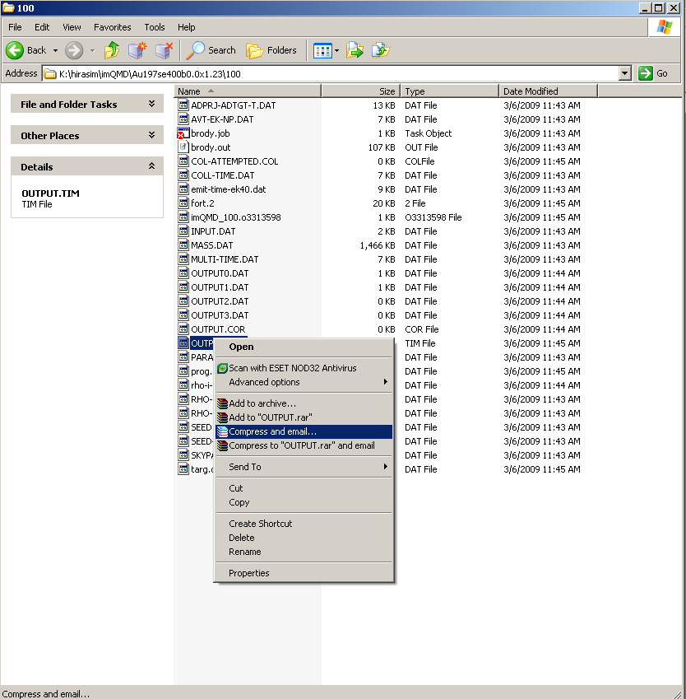
  - This is a shortcut method, you can go through START>ALLPROGRAMS>WINRAR and do it manually. But I believe this will be easier.
  - Click Compress and email.. option
  - The image should appear below
  - 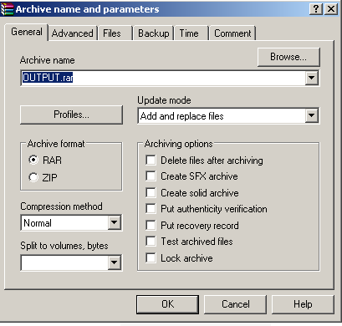
  - Here we go, You must use our naming method above where it says archive name, also note this method automatically saves your rar file to a defaulted directory specified by Winrar, so please click “Browse” button and specify where you want to save the new rar file, consult Betty to find out where she wants these files.
  - The compression method really depends on how much space is on your hard drive at the time and how you want to compress it. The default setting normal should usually be enough, but there are other options. For fast compression use “fastest” option(the rar file will be larger than normal cause of the fast compression), or you can use “Best” option(which takes longer but makes your rar file smaller than normal).
  - Lets go with “normal” for now and click ok.
  - If everything worked correctly you should see the image below
  - 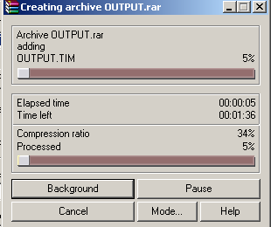
  - Once this is finished one more thing will happen with this compression method, you should see the image below
  - 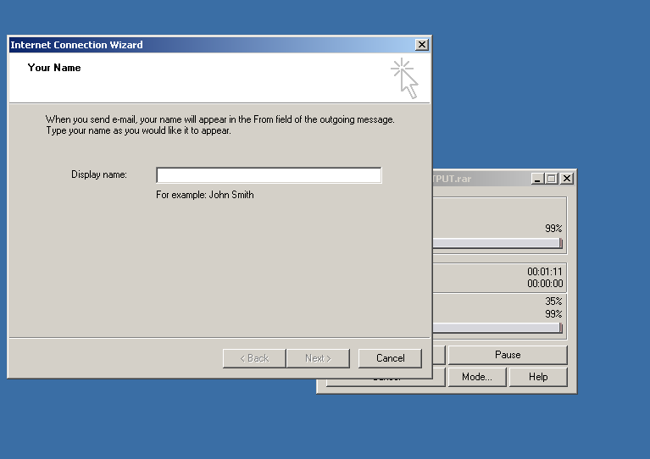
  - Your probably not going to want to send an email so click cancel and winrar error window should open, look below
  - 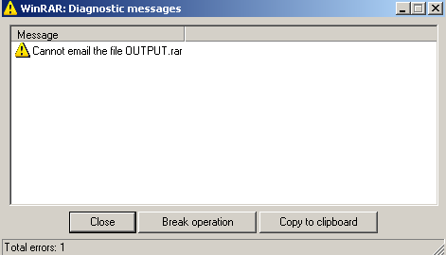
  - This is normal, your rar file was still created in the directory you specified, you just did not email the file. And your DONE!

