File permissions Windows/Linux

- Permissions for the hira/library/bettys sites can be a big problem if you don’t know what your doing and how the permissions work. At the moment of my employment and writing this tutorial the most efficient way to edit the website permissions is through linux and as far as I know modifying permissions through windows does nothing.
- So there should be a shortcut to the ssh client on your desktop or go to Start>>All Programs>>SSH Secure Shell Client you will want to click this file and something like image below should appear on your screen. 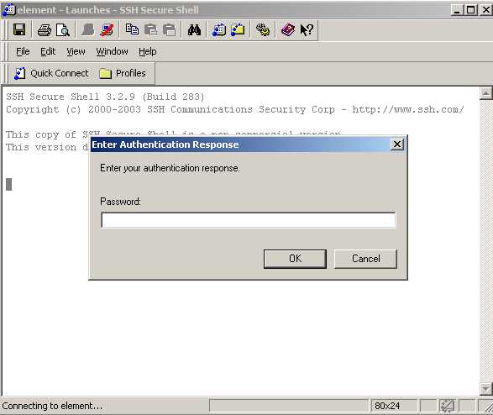
- Now this will probably not be the screen you see because my ssh client defaults the connection and trys to automatically connect, regardless if you see this click cancel, you want to get to File>>Quick Connect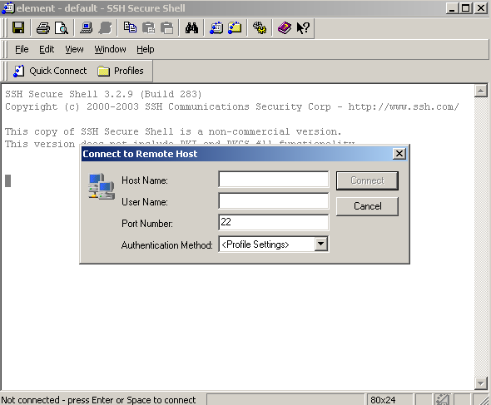
- This is the quick connect window, you'll notice we have 4 distinct fields: Host Name, User Name, Port Number, and Authentication Method. The only ones you are going to worry about is Host and User name. The host name is always “element” the username, to edit the files for bettys website, it would be wise to have betty login here under username so that you can get full write controls to edit her website.
- So now after Betty has entered her username in she will have to enter her password and click ok. Then click ok for authentication response. And you should see the image below on your screen. 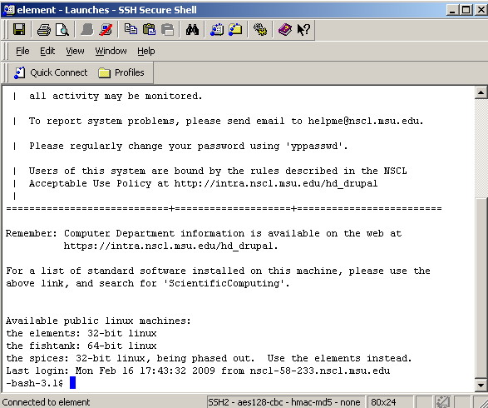
- Now you’re connected to the linux root terminal

